

**School of Engineering and Applied Science,**

**Ahmedabad University**

**CSE300 Software Engineering**

**Weekly Report**

**Guided By: Prof Khushru Doctor**

**TA Muskan Matwani**

**TA Anupama Nair**

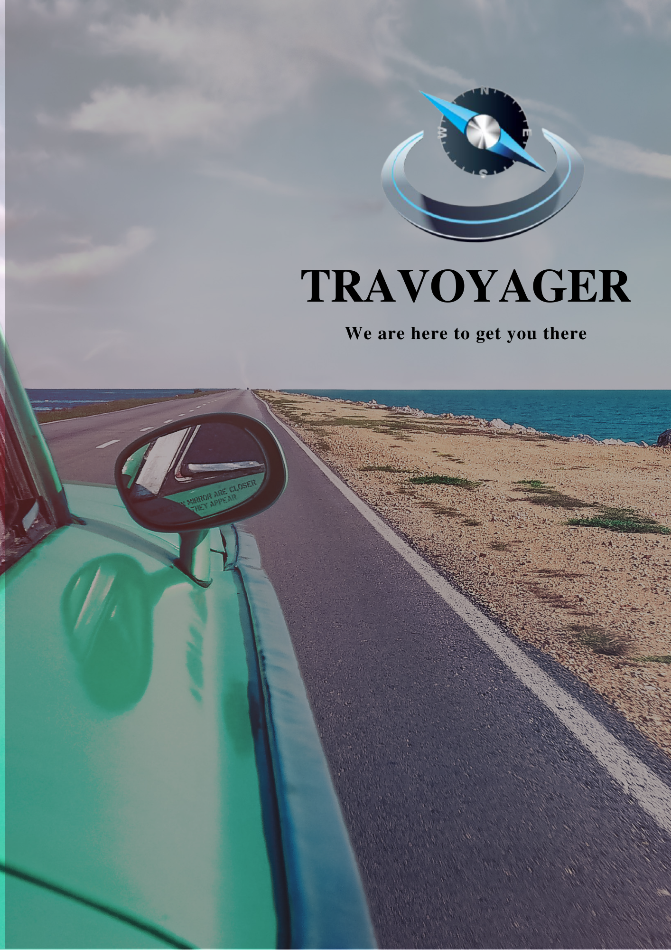

**WEEKLY MEETING REPORT - 8**

**Agenda** - Sprint 3 Discussion

**Date and Time**

**________________________________________________________________________________________________________________________________________________________________________________________________________________________________________________________________________________________________________________________________________________________________________________________________________________________________**

March 28, 2021 11:00 A.M.-12:00 P.M.

**Location**

**________________________________________________________________________________________________________________________________________________________________________________________________________________________________________________________________________________________________________________________________________________________________________________________________________________________________**

Google Meet

**Schedule**

**________________________________________________________________________________________________________________________________________________________________________________________________________________________________________________________________________________________________________________________________________________________________________________________________________________________________**

|  |  |
| --- | --- |
| **Time** | **Description** |
| 11:00-11:05 A.M. | Attendance |
| 11:05-11:30 A.M. | Progress Sharing |
| 11:30-11:45 A.M. | Backlog Discussion |
| 11:45-11:55 A.M. | Sprint 4 |
| 11:55 A.M. - 12:00 P.M. | Summary |
| 12:00 P.M. | Meeting Adjourned |

**Details**

**________________________________________________________________________________________________________________________________________________________________________________________________________________________________________________________________________________________________________________________________________________________________________________________________________________________________**

1.Progress

1. Frontend Team
   1. Design interface for user inputs that are required for generating an itinerary
   2. Discussion on changes required in the data flow, use case and state diagrams
2. Backend Team
   1. Queries completed for fetching the user inputs
   2. Queries completed for generating the itinerary

2.Backlog

1. Frontend Team
   1. Home Screen design
2. Backend Team
   1. NULL

**Conclusion**

**________________________________________________________________________________________________________________________________________________________________________________________________________________________________________________________________________________________________________________________________________________________________________________________________________________________________**

As per the sprints decided, frontend and backend teams were assigned the tasks accordingly for Sprint 4. Beginning of Sprint 4.

**Next Meeting Details**

**________________________________________________________________________________________________________________________________________________________________________________________________________________________________________________________________________________________________________________________________________________________________________________________________________________________________**

April 4 , 2021 11:00A.M. -12:00P.M.

**Next Agenda**

**________________________________________________________________________________________________________________________________________________________________________________________________________________________________________________________________________________________________________________________________________________________________________________________________________________________________**

Sprint 4 Discussion